Front end screen should cover below things:-
Subject line for front end should be Front end approval – entity Name
AI Name- Mentioned AI full Name (Legal Name)
Channel: Mobile
Order of screen should be as follows:-
- Integrated page, initial journey
- B Mnemonic logo.
- Category display page
- Biller Selection Bharat BillPay logo
- Bill fetch & Bill payment screen
- Confirmation screen & Bill payment receipt ( B assured logo)
- Complaint raising screen (CMS)
- Confirmation SMS/ Email screen

- Integrated page, initial journey
- B Mnemonic logo.

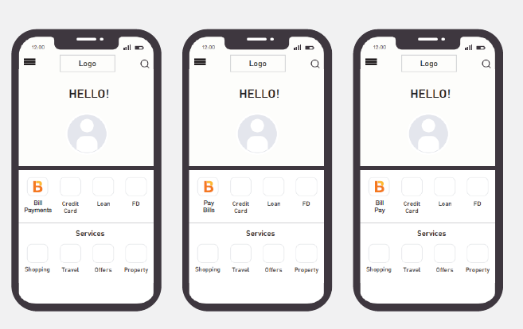
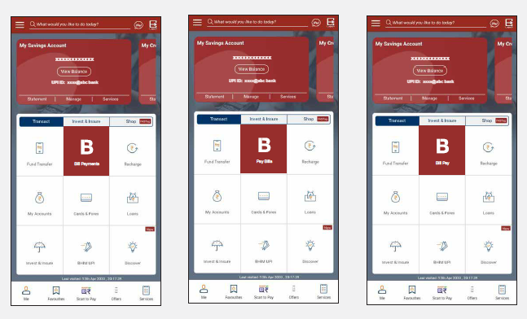

Category display page

Request you to display all BBPS category such as Housing Society, Insurance, Municipal Taxes, Education, Cable TV, Loan Repayment, LPG Gas, Gas, Water, Broadband Postpaid, Landline Postpaid, DTH, Mobile Postpaid, Electricity, Hospital, Municipal Services, Subscription Fees. Don’t show Health, Life Insurance category separately (It should be categories under Insurance)

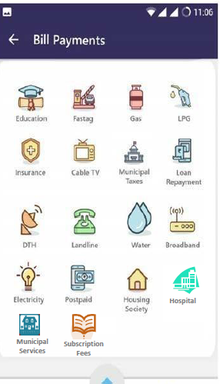

Biller selection

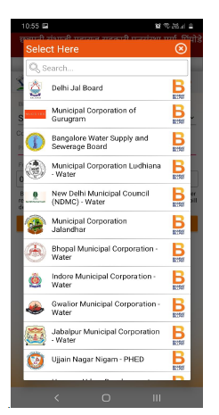

Bill fetch screen

Fetch-Bill-Details

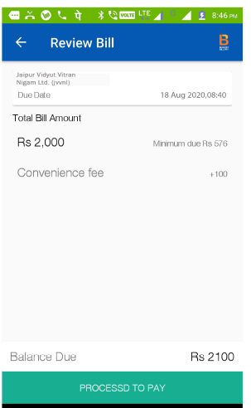
BBPS logo size should be optimum visible in above screens
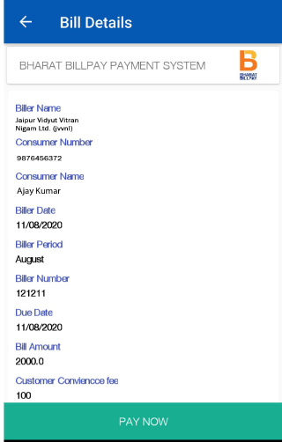
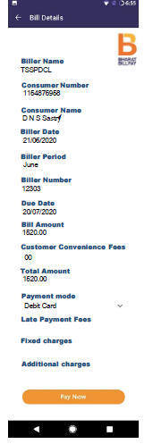

Bill payment screen

Bill-Payment-Details
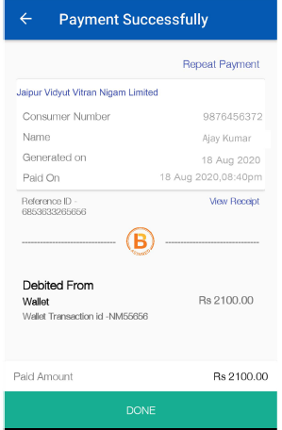

AND

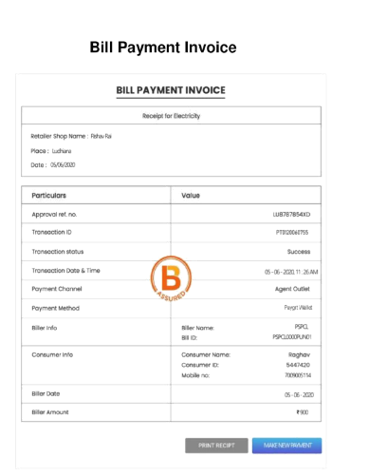
OR

B assured logo to be implemented at the middle of the page.

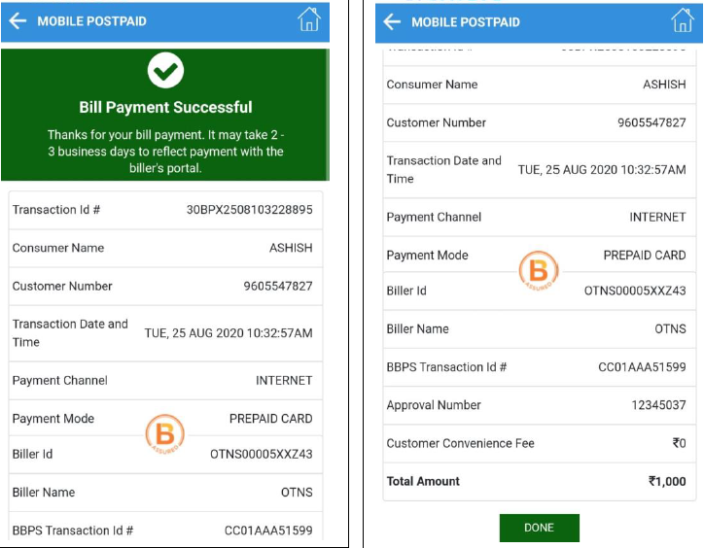

Complaint raising screen (CMS)- We need only transaction related screen. Service Related screen does not exist now.

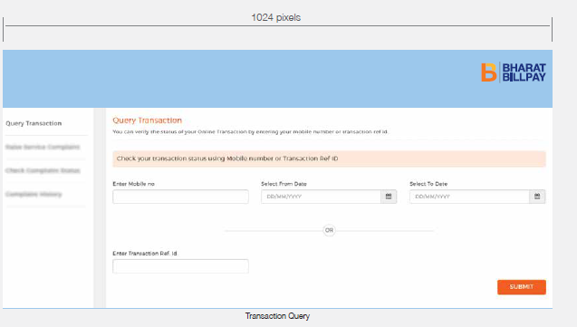
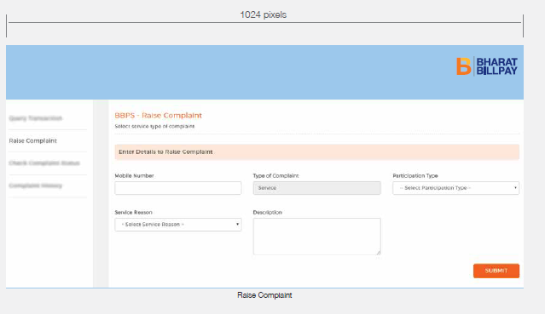
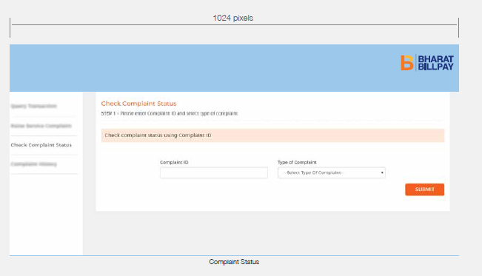

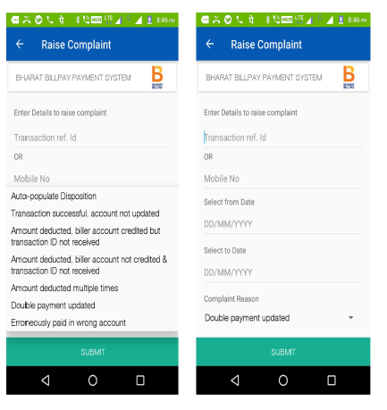
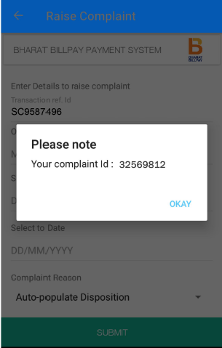

Confirmation SMS screen.

